GRADE 7 ACCELERATED · UNIT 1
Unit 1 Review
Equations and Inequalities ANSWER KEY

HOW TO USE THIS. This review covers every learning target from all ten lessons of Unit 1 — more than the assessment does. Work it in parts. If you miss two or more in a part, that part is where to spend your study time. The reference sheet has everything you need for each part.
PART A. Equivalent Forms of Rational Numbers
Lessons 1 and 2 · MA.7.NSO.1.2 · 8 questions
1. Write 7/8 as a decimal and as a percent.
7 ÷ 8 = 0.875, then multiply by 100.
Answer. 0.875 and 87.5%

2. Write 5/9 as a decimal and as a percent.
5 ÷ 9 = 0.5555… so the bar goes over the 5.
A calculator shows 0.555555556 — the last digit is rounded, not exact.
Answer. 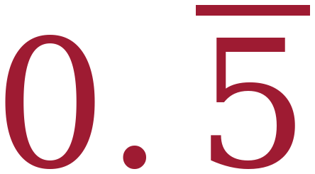 and 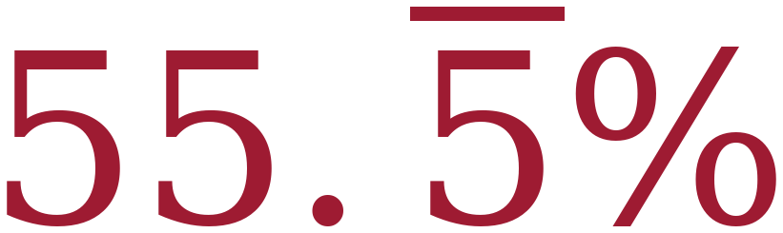

3. Write 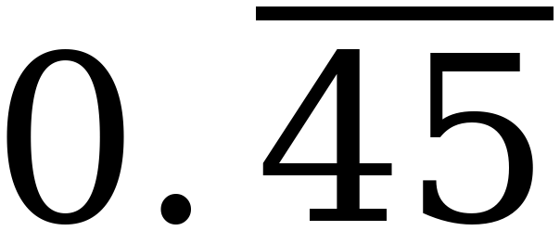 as a fraction in simplest form.
Two repeating digits, so the denominator is 99: 45/99 = 5/11.
Answer. 5/11

4. Write 0.375 as a fraction in simplest form.
375/1000, divided top and bottom by 125.
Answer. 3/8

5. Write 128% as a decimal and as a fraction.
128 ÷ 100 = 1.28, and 128/100 reduces by 4.
Answer. 1.28 and 32/25 (or 1 7/25)

6. Order from least to greatest: 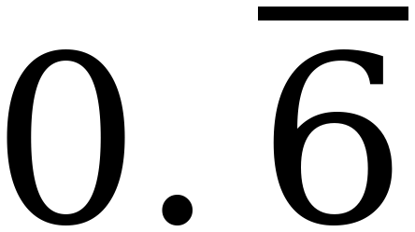, 5/8, 63%, 0.605
Write them all as decimals: 0.605, 0.625, 0.63, 0.666…
Answer. 0.605 < 5/8 < 63% < 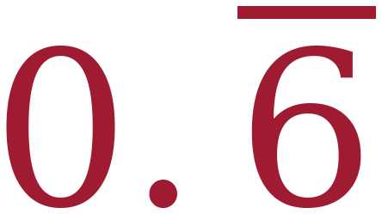

7. A calculator shows 0.555555556 when you enter 5 ÷ 9. What is the exact value, and why does the display end in a 6?
Answer. The exact value is . The calculator has a ten-digit display, so it rounds the last digit it can show.

8. Which is greater, 4/7 or 0.57 ? Show how you know.
4 ÷ 7 = 0.5714…, and 0.5714… > 0.57.
Answer. 4/7 is greater.

PART B. Solving Two-Step Equations
Lessons 3 and 5 · MA.7.AR.2.2 · 9 questions
9. SSDD. A phone plan costs $32 to start, plus $9 a month.
The four parts look alike. They are not the same question — that is the whole item, and it is why the label is on this page and not on theirs.
a. Write an expression for the total cost after m months.
No total is given, so there is nothing to solve and no equal sign.
Answer. 32 + 9m
b. The total came to $158. Write and solve an equation for m .
9m = 126
126 ÷ 9 = 14, and 32 + 9(14) = 158 ✓
Answer. 32 + 9m = 158, so m = 14 months
c. Write and solve an inequality for the whole number of months that keeps the total at $200 or less.
9m ≤ 168, so m ≤ 18.66…
Round DOWN: 18 months costs 32 + 162 = $194 ✓, and 19 months costs $203 ✗
Answer. 32 + 9m ≤ 200, so m ≤ 18.66… , and the answer is 18 months
d. What does the 32 stand for, and what does the 9 stand for?
No arithmetic. This part is asking whether the letters mean anything to you.
Answer. 32 is the one-time starting cost. 9 is the cost of each month.
Every part starts from the same two numbers. Part a is an expression and has no equal sign; part b is an equation; part c is an inequality whose answer must be rounded DOWN because it is a ceiling; part d asks what the numbers mean and needs no arithmetic at all.

10. 5x − 8 = 37
5x = 45
Answer. x = 9

11. −3n + 11 = −16
−3n = −27
Answer. n = 9

12. y/4 + 6 = 1
y/4 = −5
Answer. y = −20

13. 7(x − 3) = 42
x − 3 = 6 (divide both sides by 7)
Answer. x = 9

14. −2(m + 4.5) = 15
m + 4.5 = −7.5 (divide both sides by −2)
Answer. m = −12

15. ⅔(p − 6) = 8
p − 6 = 12 (multiply both sides by 3/2)
Answer. p = 18

16. 0.4(t + 25) = 6
t + 25 = 15 (divide both sides by 0.4)
Answer. t = −10

17. Solve 3(x + 5) = 27 two ways. Show both.
Distribute: 3x + 15 = 27, so 3x = 12 and x = 4.
Divide first: x + 5 = 9, so x = 4.
Answer. x = 4

PART C. Writing and Solving Equations from a Situation
Lessons 4, 6 and 7 · MA.7.AR.2.2 · 6 questions
18. A gym charges $45 to join plus $22 a month. A member has paid $221 in all. How many months of membership is that?
m = the number of months. 45 + 22m = 221
22m = 176, so m = 8
Answer. 8 months

19. A restaurant bill was reduced by a $9 coupon and then split evenly among 6 friends. Each friend paid $12.50. What was the bill before the coupon?
b = the bill before the coupon. (b − 9) / 6 = 12.50
b − 9 = 75, so b = 84
Answer. $84.00

20. Five concert tickets were bought and a $3.25 service fee was added to each one. The total was $91.25. What was the price of one ticket before the fee?
t = the price of one ticket. 5(t + 3.25) = 91.25
t + 3.25 = 18.25, so t = 15
Answer. $15.00

21. Elena earns $520 a week plus a 4% commission on her sales. Last week her total earnings were $732. How much did she sell?
s = her sales. 520 + 0.04s = 732
0.04s = 212, so s = 5,300
Her commission was $212 — not $732.
Answer. $5,300

22. A coat is marked 35% off. After the discount, Kai uses a $12 coupon and pays $53.00. What was the original price?
p = the original price. 0.65p − 12 = 53
0.65p = 65, so p = 100
35% off means paying 65%.
Answer. $100.00

23. A tank held 3,600 gallons and is draining at 145 gallons per hour. It now holds 1,570 gallons. How long has it been draining?
h = the number of hours. 3,600 − 145h = 1,570
145h = 2,030, so h = 14
Answer. 14 hours

PART D. Solutions to Inequalities, and Graphing Them
Lesson 8 · MA.8.AR.2.2 · 6 questions
24. Circle every value that is a solution to 2x − 7 ≥ 5. −2 0 5.9 6 6.1 12
2x ≥ 12, so x ≥ 6.
6 counts because the symbol has the equal bar. 5.9 does not.
Answer. 6, 6.1, 12

25. Solve and graph: 4x − 3 ≥ 1
4x ≥ 4
Answer. x ≥ 1

26. Solve and graph: −2x + 3 > 13
−2x > 10, then divide by −2 and REVERSE.
Answer. x < −5

27. Solve and graph: x/2 − 1 > 1
x/2 > 2, then multiply both sides by 2.
Answer. x > 4

28. Solve and graph: 7 − x ≥ 16
−x ≥ 9, then multiply by −1 and REVERSE.
Answer. x ≤ −9

29. Explain how you know that 0.5 is not a solution to 3x + 1 > 2.5.
Answer. Substituting gives 3(0.5) + 1 = 2.5, and 2.5 > 2.5 is false. The two sides are equal, and the symbol is strict.

PART E. Inequalities with the Distributive Property
Lesson 9 · MA.8.AR.2.2 · 5 questions
30. Solve and graph: 4(x + 1) ≤ 12
x + 1 ≤ 3 (divide both sides by 4 — no reversal)
Answer. x ≤ 2

31. Solve and graph: −3(x − 1) < 9
x − 1 > −3 (divide both sides by −3 and REVERSE)
Answer. x > −2

32. Solve and graph: ⅕(x + 6) < 3
x + 6 < 15 (multiply both sides by 5 — no reversal)
Answer. x < 9

33. Solve −2(3x − 5) ≥ 22 two ways. Show both.
Distribute: −6x + 10 ≥ 22, so −6x ≥ 12 and x ≤ −2 (reversed at the division).
Divide first: 3x − 5 ≤ −11 (reversed here), so 3x ≤ −6 and x ≤ −2.
Answer. x ≤ −2

34. Sam solved −4(x + 2) > 8. He distributed the −4 and reversed the symbol, then divided by −4 and reversed again. What went wrong, and what is the correct solution?
Distributing rewrites one side. It is not an operation on both sides, so nothing reverses there.
Sam reversed twice, which returns the symbol to where it started, so he got x > −4 — backwards.
Correct: −4x − 8 > 8, so −4x > 16, and x < −4 (one reversal, at the division).
Answer. The correct solution is x < −4.

PART F. Inequalities in Real-World Situations
Lesson 10 · MA.8.AR.2.2 · 5 questions
35. Write an inequality: a ride requires riders to be at least 48 inches tall. Use h for a rider's height in inches.
“At least” includes the number, so the symbol is ≥ and the graph would use a closed circle.
Answer. h ≥ 48

36. A field trip costs $180 plus $14 for each student. The budget is $630. How many students can go? Justify your answer.
s = the number of students. 180 + 14s ≤ 630
14s ≤ 450, so s ≤ 32.14…
Round DOWN — it is a maximum. 32 students cost $628; 33 would cost $642.
Answer. 32 students

37. Marisol needs at least $185 for a bike. She has $40 and will save the same amount each week for 8 weeks. What is the least she can save each week?
w = the amount saved each week. 40 + 8w ≥ 185
8w ≥ 145, so w ≥ 18.125
Round UP — it is a minimum. At $18.12 she reaches $184.96 and misses; at $18.13 she reaches $185.04.
Answer. $18.13 a week

38. A store sells ¾ of the items on a shelf, then brings out 60 more. The store keeps at least 200 items on the shelf. How many items were on the shelf to begin with?
x = the number of items to begin with. One quarter are left, so ¼x + 60 ≥ 200.
¼x ≥ 140, so x ≥ 560
Answer. At least 560 items

39. A phone plan costs at most $50 a month. It charges $28 plus $0.11 for each gigabyte of data. How many whole gigabytes can be used?
g = the gigabytes used. 28 + 0.11g ≤ 50
0.11g ≤ 22, so g ≤ 200
This one is already a whole number, so nothing needs rounding.
Answer. 200 gigabytes

PART G. Looking Ahead: the Unknown on Both Sides
Later this year · MA.8.AR.2.1 · 2 questions
40. Solve 5(n − 2) = 3n + 8.
5n − 10 = 3n + 8 (distribute first)
2n = 18
Answer. n = 9

41. Plan A costs $60 to join plus $8 an hour. Plan B costs $20 to join plus $12 an hour. At how many hours do the two plans cost the same?
60 + 8h = 20 + 12h
40 = 4h, so h = 10
Answer. 10 hours, at $140 each

